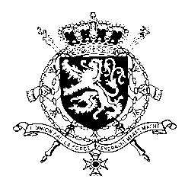
Représentation permanente de la Belgique auprès des Nations Unies et auprès des institutions spécialisées à Genève

WG UPR 26 – South Sudan
Belgian Intervention
7th of November 2016

Mr. President,
Belgium wishes to congratulate South Sudan as the newest member of the United Nations and wishes it every success in the exercise of its first Universal Periodic Review.
We welcome the fact that South Sudan has already ratified some of the core human rights treaties and has accepted the complaint mechanisms under these treaties. We invite South Sudan to continue on this path, and therefore recommend:
R1. To ratify the Convention on the Prevention and Punishment of the Crime of Genocide, the International Covenant on Civil and Political Rights and the International Covenant on Economic, Social and Cultural Rights.
As areas of concern, we note the persistence of sexual and gender-based violence and the low level of school attendance. We would therefore like to formulate the following two recommendations:
R2. To adopt a comprehensive law addressing all forms of violence against women and girls.
R3. To effectively implement the General Education Act, in particular by taking measures to improve school enrolment rates.

I thank you, Mr. President

